
Follow us on Facebook
Join our community



Patient and Community Collaboration Group Newsletter
Hull Edition
Summer 2026
Suicide Awareness

World Suicide Prevention Day
As September approaches, we will observe World Suicide Prevention Day. We want to raise awareness, encourage open conversations about mental health, and remind everyone that support is available. A simple conversation, a listening ear, or reaching out to someone who may be struggling can make a meaningful difference. Together, we can create a caring community where everyone feels heard, valued, and supported.
If you need help, are worried about someone, or simply need to talk, the following organisations can provide support:

Crisis and immediate support

Urgent mental health support for adults in Hull and the East Riding - Call 0800 138 0990 (24 hours). Support is available for people experiencing a crisis and for anyone worried about someone else.

NHS 111 — select the mental health option for urgent support, advice, and signposting.
Call 999 if there is an immediate danger or someone is unable to keep themselves safe.
You can also visit A&E for emergency support.

Other support services
- NHS Every Mind Matters
- Calm — www.calm.com
- MindShift CBT — www.mindshiftcbt.com
- Daylio — www.daylio.net
- Stay Alive — www.stayalive.app

To mark Suicide Awareness Month, our Haxby Hull colleagues are organising a bake-off to raise awareness. All proceeds will support mental health and suicide prevention initiatives.

MSK Service Update: Cora Health
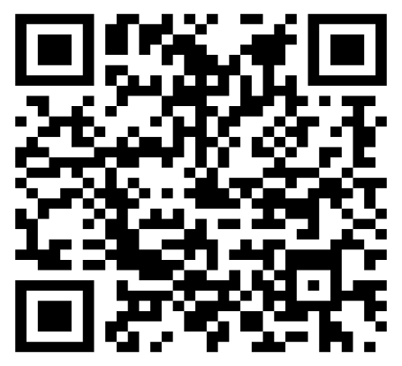
In January 2025, Healthshare merged with Connect to form Cora Health. Patients continue to receive the same service from the same staff, now under the Cora Health name.
This change has enabled the team to streamline processes, including patient booking, and focus even more closely on delivering an outstanding clinical service.
The best way to access the service is by self-referral. Call 01482 300 003, visit corahealth.co.uk, or use the QR code provided.
You Said, We Did
Here are some examples of patient feedback and the action we have taken.
You said: “Older people can struggle with online requests and using the internet.”
We did: A new system will be introduced in October to make the process easier.
You said: “There is confusion about sending in samples and patients sometimes miss the laboratory collection time.”
We did: We reminded staff to clearly explain cut-off times and displayed posters at our sites showing the final sample drop-off time.
You said: “Parking spaces at Kingswood are often taken during the school run, making it difficult for patients to park.”
We did: We installed signs in the car park and are continuing discussions about possible solutions. The school has also asked parents to avoid using the surgery car park where possible.

Inside Haxby Group
Haxby Group has many departments working together to ensure each patient’s journey through the practice runs smoothly. Our Patient Services Team is usually the first point of contact.

A day in the life of a Patient Services Adviser
Each day, we support patients at the front desk and by telephone. We help with a wide range of queries, including booking appointments, following up clinician requests, communicating test results, processing prescription requests, filing blood test results, and completing follow-up tasks. We also support patients with additional needs, such as arranging a wheelchair for someone with limited mobility.
Our role is to keep each patient’s journey moving smoothly, from the first request through to the outcome.

Patient’s Thank You
- Thinking back to the lockdown days of Covid, many of us took to our front doors and clapped for the NHS. We appreciated that our medical professionals and their support staff were still providing a GP service, albeit a little differently.
- The telephone lines were still answered; it was still possible to speak to a doctor and often in a time of need there was still someone to help.
- Time has passed and now we appear to be back to a new normal.
- After speaking to colleagues at work, I wanted to put something in writing to recognise what a great GP surgery we have at Kingswood. Ok, not everything is perfect, but my colleagues don’t have a surgery that operates the long hours that Kingswood does, they don’t have a plethora of services offered on site that Kingswood offer, and they seem to have longer wait times for appointments.
- I want to recognise the staff on the front desk for the difficult job that they do, they always appear to be friendly, yet professional despite regularly being asked to do the impossible. Waiting in the queue to speak to reception the other day I witnessed someone being so rude to the receptionist I was almost embarrassed and yet the receptionist took the poor behaviour in their stride.
- Maybe it’s time to recognise that the receptionist is human too, they are doing a difficult job and trying to do the right thing for everyone.
- Our surgery has a fantastic team of medically trained people and a great support team too, and we should treat the team the same as we would want to be treated.
- If clapping or banging pans was the right thing to do in covid times to recognise our surgery and our medical people, I for one will continue to acknowledge the great work done by the Kingswood team.
- It’s easy to complain when things are not to one’s liking however I genuinely believe that we have a great surgery with great people who want to help.’

Shared with permission by a Haxby patient.
Well done to participants across Haxby who took part in the Muddy Race to raise funds for Cancer Research on Saturday 25th July 2026.
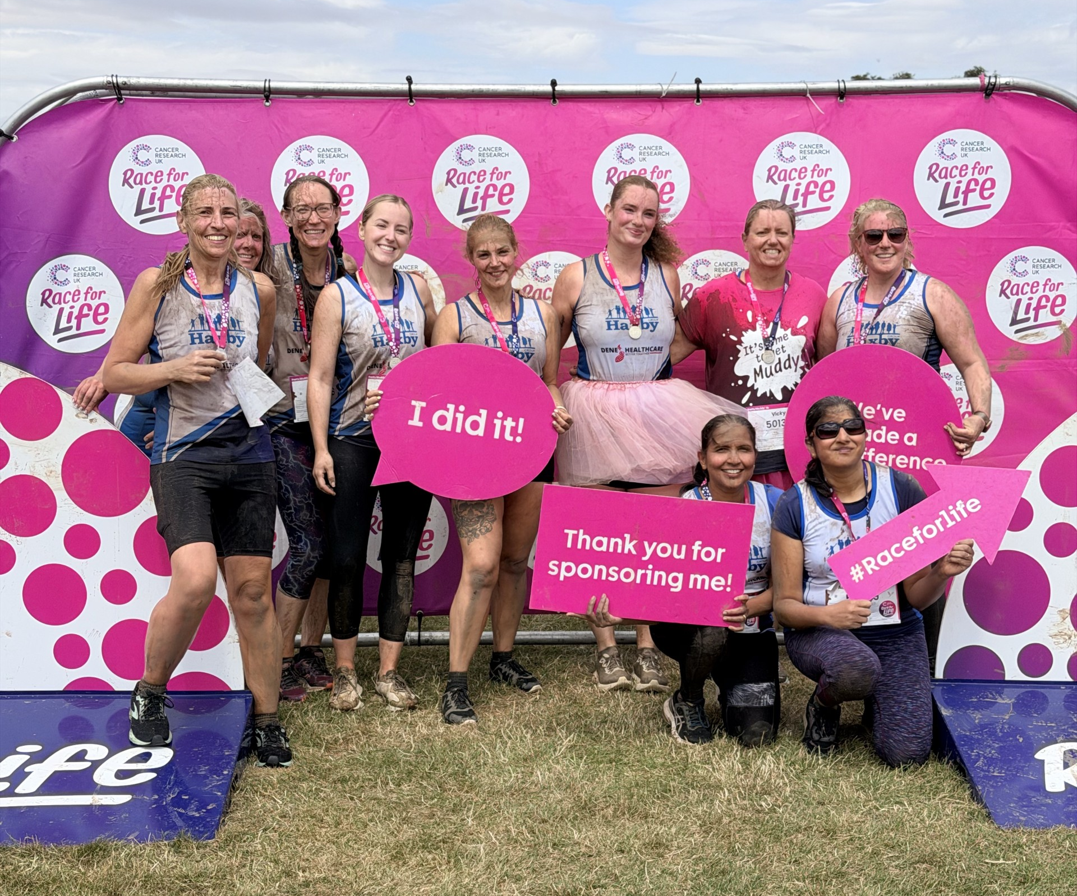
Thank you for reading.
If you would like to join the Our Haxby Community meeting group—as a representative of a local organisation or as an individual—and help shape and improve the care we provide, please contact hnyicb-ny.haxbypatientexperience@nhs.net.
We also welcome ideas for future editions and contributions to our art section, including paintings, drawings, photographs, and poems. Please use the email address above.

