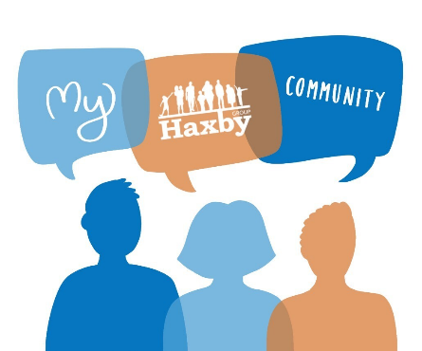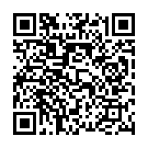
Our Haxby Community Newsletter
Hull edition
May 2025
Autism awareness month

Message from Dr Witney, GP Partner
Autism, or Autism Spectrum Disorder (ASD), is a condition which affects how a person communicates and interacts with the world around them. It is called a "spectrum" because it encompasses a wide range of symptoms and abilities and no two autistic people are the same; all have unique traits, needs and strengths that make them the person they are, and their experiences can vary widely.

We know that appropriate support tailored to the individual's needs can significantly improve an autistic person’s quality of life and make it easier for them to navigate the challenges of everyday life. As a community, we can support autistic individuals by creating an inclusive environment, promoting awareness, and encouraging acceptance. As a healthcare organisation we can also help by providing well informed, non-discriminatory needs-based care, and by working hand-in-hand with our local support services. Some of these are listed below:

Who can help and where to look
- Matthews Hub: A support service for people aged 13 and over who are autistic without a learning disability; and those awaiting a diagnosis - https://matthewshub.org/
- Early Help Family Support (SEND): Supporting parents/carers of children with complex health needs and disabilities
01482 715 155 - https://www.hull.gov.uk/family-support/early-help-family-support
https://hullsendlocaloffer.org.uk/
- KIDS - Hull Special Educational Needs & Disabilities Information Advice and Support Service (SENDIASS): Supporting people aged 0-25 years with Special Education Needs
01482 467 541 - http://www.kids.org.uk/Hull-sendiass - sendiassduty@kids.org.uk
- Aim Higher: Autism / neurodiversity support for families of children and young people
https://www.aimhighercharity.com/
- Leisure and Family Support Service (LAFSS): Non-residential short breaks service
01482 715 155 - lafss@hullcc.gov.uk
- Hull Befriending Service: Trained volunteer befrienders for autistic people
01482 467 540 - hullbefriending@kids.org.uk

What else is going on
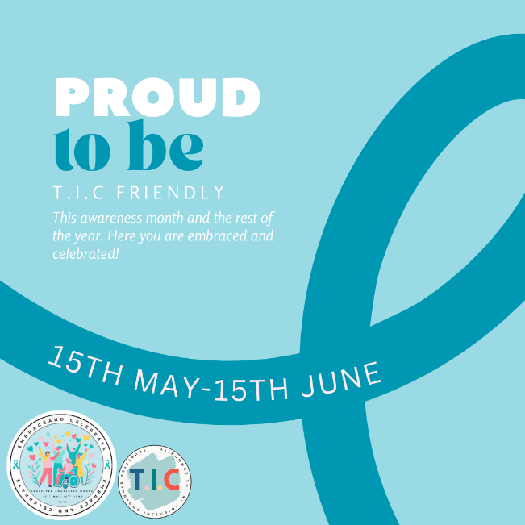
It’s also Tourette Syndrome Awareness Month! We are so proud to be a T.I.C friendly establishment, this means that we have made a promise to embrace and celebrate those who use our establishment with Tourettes Syndrome and Tic disorders. We have had training to educate us on the condition and made adaptions to our practice to further our inclusion.

Please see www.tic-yorkshire.co.uk for more information on the condition
Staff and patient art of the month
Artwork by Neil Jackson. Completed at the free art sessions held in the Community Room at the Orchard Centre on Wednesdays and Fridays: lifecollege@notdull.org – 01482 326196
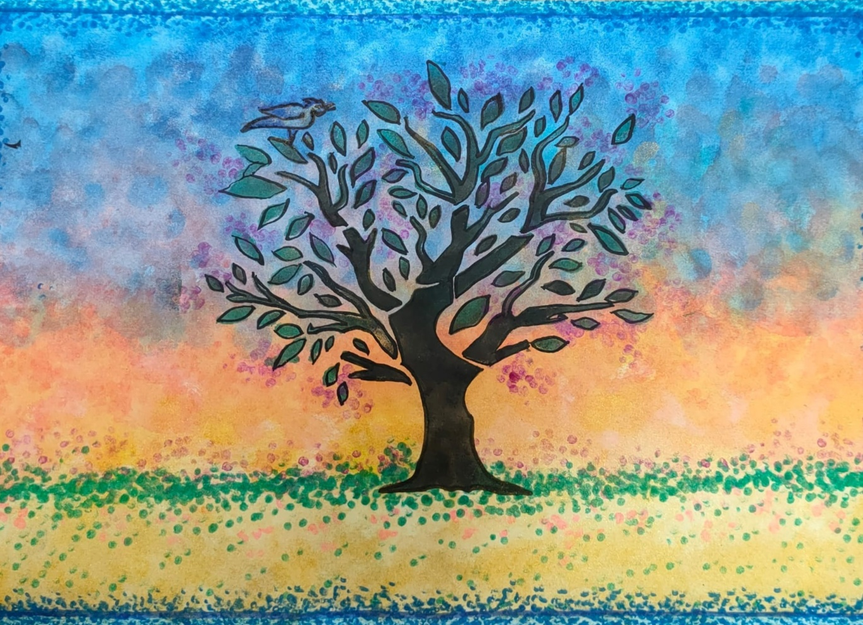

Thank you for reading. If you would like to join the Our Haxby Community meeting group, either as a local organisation representative or as an individual, to help shape and improve the care we provide, please let us know at: hnyicb-ny.haxbypatientexperience@nhs.net

If you have any ideas for future newsletter editions, or would like to contribute a painting, drawing, photo or poem to our art section, please also let us know at the above email address.

