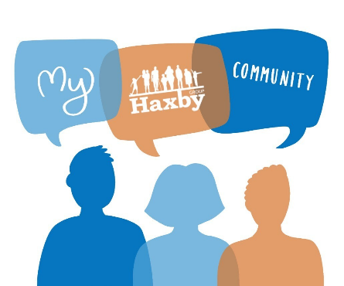
Our Haxby Community Newsletter
Hull edition
March 2025
Domestic abuse awareness month

Message from Dr Witney, GP Partner

This March, we are focusing on domestic abuse. This is a serious and sadly common issue that affects many people in our community. In Hull, over 600 victims receive support for domestic abuse every month. This includes nearly 900 affected children.

Domestic abuse can be physical, emotional, controlling, financial or sexual, and its effects can stay with sufferers for a long time, particularly if it is repeated. It is also often easily dismissed, ignored or normalised. It is therefore vital to raise awareness and to support all those involved.

At Haxby, we want everyone to feel safe and cared for. If you or someone you know are experiencing domestic abuse, please reach out to us or to one of the fantastic local organisations listed below for confidential support. Your safety and wellbeing are our top priorities. By working together, we can create a safe and supportive community.

Who can help and where to look
- Hull Domestic Abuse Partnership: Local support service for domestic abuse victims:
https://www.hull.gov.uk/hullDAP/ - 01482 318759 (female support) - 01482 613978 (male support)
- Hull Women’s Aid (West Hull):
www.hullwomensaid.org (live chat) - 01482 446099 - enquiries@hullwomensaid.org
- Preston Road Women’s Centre (East Hull):
https://www.purplehouse.co.uk/domestic-violence-support-service/ - 01482 790310 -
info@purplehouse.co.uk
- Together Women (Central Hull):
https://www.ciacadvice.com/ - 01482 218125 - hull@togetherwomen.org
- Early Help and Safeguarding Hub (EHASH): Local family and child safeguarding support
https://www.hull.gov.uk/family-support/early-help-family-support - 01482 448879 (opt. 4)
- Strength to Change: Confidential support for men to stop domestic violence
https://hullstrengthtochange.org/ - 01482 613403
- Hull Rape Crisis and Sexual Abuse Service:
01482 329 990 - hrcsas@hullrapecrisis.org

What else is going on

On April 7th and 8th, all Haxby Hull practices (Newington, Kingswood, Orchard Park and Burnbrae surgeries) will merge into one practice called Haxby Group Hull, still spread across these 4 sites.

To enable this change, our clinical systems will not work on April 7th and 8th from 3pm onwards. During this time, we cannot access patient details. Please order repeat medications before April 5.

After the merge, you will still have access to GP services at your usual practice and now also have access to evening and weekend appointments at both Kingswood and Newington Surgeries. You can contact the practice for appointments online, in person, or by telephone using your practice's existing phone number. There will be no change to the clinical team or clinical care. If you currently use SystmOnline, this service will no longer be available. We encourage you to register for the NHS App.

If your NHS App does not work correctly after the merge, delete and re-install it. If you still have trouble, please contact us for support and we’ll be happy to help. Thanks for your understanding.

Staff and patient art of the month
“Say cheese” – photo by Kara Savage, Social Prescriber


Thank you for reading. If you would like to join the Our Haxby Community meeting group, either as a local organisation representative or as an individual, to help shape and improve the care we provide, please let us know at: hnyicb-ny.haxbypatientexperience@nhs.net

If you have any ideas for future newsletter editions, or would like to contribute a painting, drawing, photo or poem to our art section, please also let us know at the above email address.

