
Our Haxby Community Newsletter
Hull edition
February 2025
Asylum seeker and refugee month

Message from Dr Witney, GP Partner

To all our patients who are asylum seekers, refugees, and migrant workers, welcome! bun venit! mile widziany! أهلًا وسهلًا ! بەخێرهاتن ! добро пожаловать! sveikas atvykęs! laipni lūdzam!

We consider the provision of healthcare a fundamental right, irrespective of what cultural background you come from, which country you were born in, or what religion you practice. We will always aim to provide high quality care with respect and consideration for you as an individual.

If you are an asylum seeker or refugee or have travelled here from elsewhere and are struggling to adapt to life in Hull, please see below for some of our fantastic local groups who can help support you. Please know that you do not require identification to register at our practice.

Who can help and where to look
- Open Doors: Welcoming and helping asylum seekers, refugees and migrant workers
Drop-in sessions every Thursday, 10am - 3pm at 91 Princes Avenue HU5 3QP
https://open-doors.org.uk/ - 01482 345 132 - manager@open-doors.org.uk
- Welcome House: Empowering asylum seekers and refugees to build fulfilling lives in Hull
https://welcomehousehull.org.uk/ - 01482 205 880 - hello@welcomehousehull.org.uk
- Humber All Nations Alliance: Offering support for minority ethnic & migrant communities https://hanaonline.co.uk/ - 01482 491 177 - admin@hanaonline.org.uk
- Humber Community Advice Services (H-CAS): Free independent advice on issues relating to money, housing, employment, benefits, immigration, health and well-being
https://h-cas.org.uk/ - 01482 236460 - https://h-cas.org.uk/contact/
- Community Integration Advocacy Centre: Offers free and low-cost immigration advice
Drop-in sessions every Thursday, 10am - 12pm at Prince’s Avenue Methodist Church, 91 Prince’s Ave HU5 3QP
https://www.ciacadvice.com/ - CIACAdvice@gmail.com
- Hull Sisters: Confidential advice and support for black and minority ethnic women and girls
https://hullsisters.org/ - 07539 321502 - sisters@hullsisters.org
- Welcome to English: Helping newcomers to Hull learn English and make friends
https://www.welcometoenglish.org/ - 07791 530039 - karenvandiesan@outlook.com

What else is going on

New Pocketalk translation device

We know that those who do not speak English as a first language face barriers in accessing healthcare, and that this can be a particular issue for patients at the reception desk. We have therefore introduced a new Pocketalk translation device at our Newington Surgery, and plan to bring this to all our surgeries in due course.

Period poverty

It is the unfortunate case that for many women and girls it can be a struggle to afford period products every month. We have set aside some boxes of period products behind our reception desks for anyone in this position. Please don’t hesitate to ask at the desk if you feel you need this.

Local team of the month
The ‘Open Doors’ volunteer team
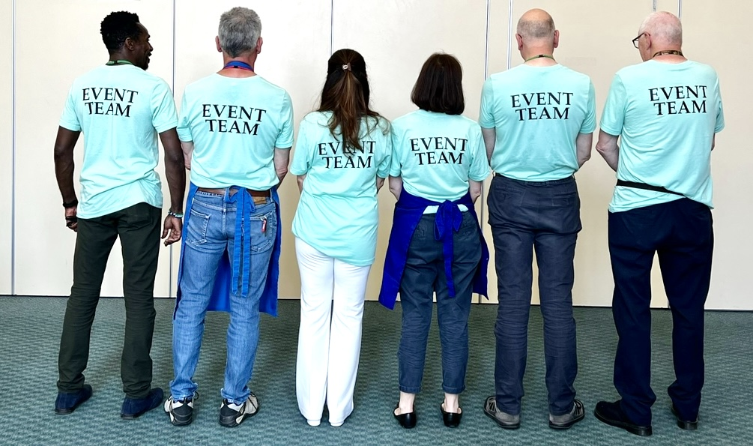

Thank you for reading. If you would like to join the Our Haxby Community meeting group, either as a local organisation representative or as an individual, to help shape and improve the care we provide, please let us know at: hnyicb-ny.haxbypatientexperience@nhs.net

If you would like to contribute any ideas for future newsletter editions, or to contribute a photo to champion your local team, please also let us know at the above email address.

