
Our Haxby Community Newsletter
Hull edition
January 2025
Health and weight awareness month
Message from Dr Witney, GP Partner

Happy New Year!

As we step into a new year, many of us reflect on our health and how we can make positive changes. One of the most significant factors influencing overall health is weight, with nearly two-thirds of adults in the UK currently classified as overweight or obese. This isn't just about numbers on the scales – excess weight can increase the risk of serious conditions such as diabetes, heart disease, and even certain cancers.

At Haxby, we’re committed to supporting you on your health journey. Whether it’s through providing personalised advice, referring you to local weight management services, or connecting you with schemes like the NHS Couch to 5K app or local activity classes, there’s help available. Small changes can make a big difference to your health and wellbeing over time.

Wishing you health and happiness in 2025.
Who can help and where to look
- NHS weight loss app: Support to help you make small sustainable weight improvements
https://www.nhs.uk/better-health/lose-weight/
- NHS couch to 5k: A guided running plan for absolute beginners
https://www.nhs.uk/live-well/exercise/get-running-with-couch-to-5k/
- Love it gym discount: Discount for pensioners, those with disabilities or claiming benefits
https://www.liveithull.co.uk/memberships/love-concessionary-membership
- Nuffield Health joint pain programme: Free exercise programme for those with joint pain
https://www.nuffieldhealth.com/about-us/our-impact/healthy-life/joint-pain-programme
- Love exploring: Walking routes and activities for the whole family around Hull’s parks
https://www.travelhull.co.uk/walk/love-exploring
- Active Humber: Local clubs and activities
https://activehumber.co.uk/
- Fit Mums: Local exercise classes for women of all ages, stages and abilities
https://fitmums.org.uk/
- Man V Fat: Loose weight and play football! For any local men with a BMI of over 27.5
https://www.manvfatfootball.org/ help@manvfat.com 0345 163 0042

Local team of the month
The Picking and Ferens team getting active during their exercise sessions
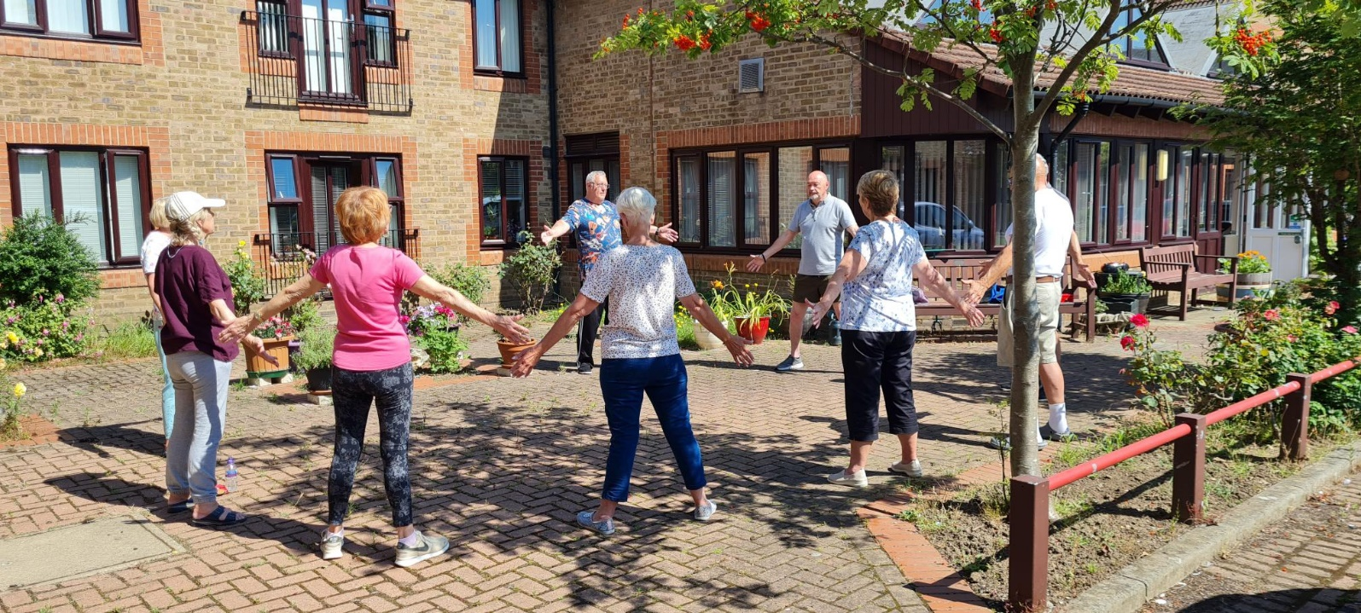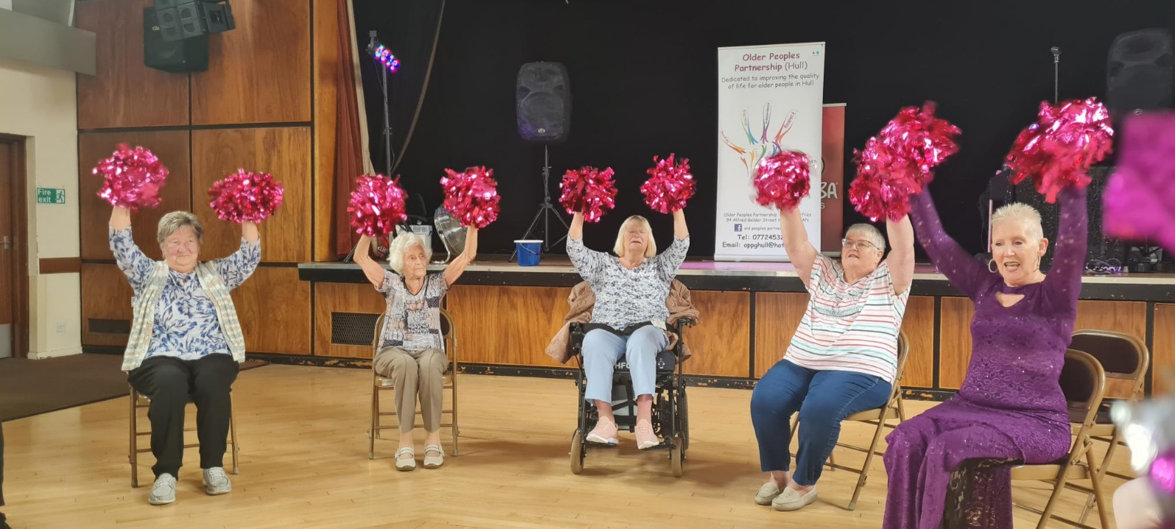

Thank you for reading. If you would like to join the Our Haxby Community meeting group, either as a local organisation representative or as an individual, to help shape and improve the care we provide, please let us know at: hnyicb-ny.haxbypatientexperience@nhs.net

If you would like to contribute any ideas for future newsletter editions, or to contribute a photo to champion your local team, please also let us know at the above email address.

