
Our Haxby Community Newsletter
Hull edition
November 2024
Cost of living awareness month

Message from Dr Witney, GP Partner
Many of our patients and members of our community in Hull are struggling with the increasing cost of living, and sadly, more and more of us are falling into poverty.

Poverty comes with its own cost. Not only the struggle to fill your fridge, warm your home, or know that you can keep roof over your head for the years to come, but also the mental and social pressure that can come with these stresses.

If we are serious about our goal to improve the health of our community (and we are), it is important that we acknowledge that poverty and cost of living pressures play a large role in our health, wellbeing and dignity.

There is much that can be done to help. Please remember that you do not have to manage these pressures alone.

Who can help and where to look
- Hull City Council support: Central resource for local support
https://www.hull.gov.uk/cost-living-support-1/cost-living
- Turn2us: Charity providing practical help for people who are struggling financially
https://www.turn2us.org.uk/
- Immediate financial help: Help for people unable to meet immediate short-term needs
https://www.hull.gov.uk/debt-money/immediate-financial-help
- Warm Homes Team: Service for those having difficulty heating their homes
https://www.hullwarmhomes.org.uk/
- Warm Spaces Hull: Map of places across the city to get warm and enjoy a little company
https://maps.hull.gov.uk/?tab=maps&Layers=Warm_Spaces
- Community Food Support: food banks, pantries, and other places offering affordable food
https://nurturehull.org.uk/community-food-aid-providers/
- Hull Food Banks: Provide foodbank vouchers to help combat poverty and hunger
https://hull.foodbank.org.uk/contact-us/
- Citizens Advice Bureau: Free impartial advice for anyone struggling financially
https://www.hullandeastridingcab.org.uk/

What else is going on


Activities at Londsdale Community Centre

The Londsdale Community Centre offer a wealth of cost-of-living projects, activities, skills sessions, and twice weekly food banks. Their food banks are every Tuesday morning at 11am and Friday afternoon at 1pm.

They can be found at: Lonsdale community centre, 8 Lonsdale Street, Hull, HU3 6PA

For more information, click the below link or scan the QR code to the right.

https://lonsdalecc.org.uk/what-on/

Local team of the month
Dave and Paul from the Londsdale Community Centre
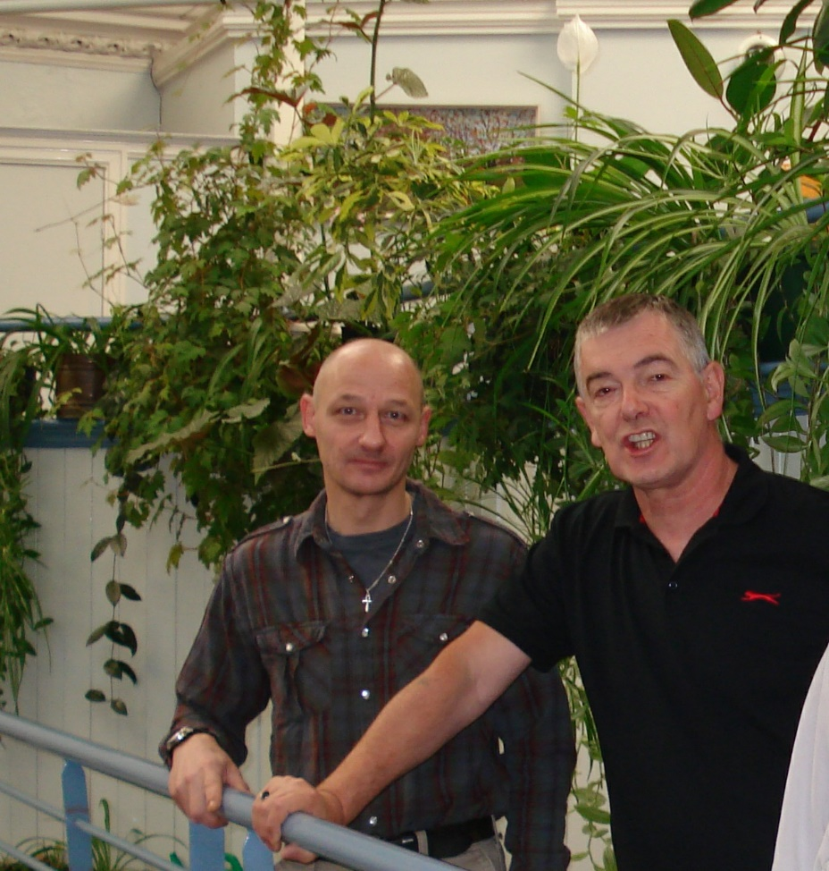

Thank you for reading. If you would like to join the Our Haxby Community meeting group, either as a local organisation representative or as an individual, to help shape and improve the care we provide, please let us know at: hnyicb-ny.haxbypatientexperience@nhs.net

If you would like to contribute any ideas for future newsletter editions, or to contribute a photo to champion your local team, please also let us know at the above email address.

