
Our Haxby Community Newsletter
Hull edition
December 2024
Loneliness awareness month

Message from Dr Witney, GP Partner

We will all experience the feeling of loneliness at certain times in our lives. It’s possible to feel lonely in a busy city like ours, when with others or by ourselves, or when using social media.

Loneliness is more than just a “bad feeling”. It can cause unwelcome feelings of isolation, disconnection, and sadness. We are more likely to feel anxious and depressed when we feel lonely.

It can be difficult to admit to ourselves and to others when we feel lonely, which can make this feeling worse. It’s important to remind ourselves that lots of people will be experiencing similar feelings of loneliness, and that the feeling can pass.

If you are feeling lonely and feel that you have no-one to reach out to, please see below for some of the fantastic people and organisations who can help support you. You are not alone.
Who can help and where to look
- Age UK: Helping people living in Hull aged over 50 with home support and befriending
https://www.ageuk.org.uk/hull/about-us/contact-us/ 01482 324 644
- British Red Cross: Helping you settle back in after a stay in hospital
healthandcarenorthiomadmin@redcross.org.uk 01482 499830
- The Warren Youth Project: Support, training and activities for young people in Hull
47-48 Queens Dock Avenue, HU1 3DR 01482 218 115
- The Goodwin Centre: Craft / bingo / English classes / sewing / yoga / work support
The Octagon, Walker Street https://goodwintrust.org/ 07791530039
- Lonsdale Centre: Activity groups, food bank, community shop, fuel and debt advice
8 Lonsdale Street, HU3 6PA www.lonsdalecc.org.uk 01482564691
- The Shed: Weekly craft groups, energy and debt support
108 West Dock Ave, Hu34JR Hull@groundwork.org.uk 07963028560
- West Hull Community Hub: Social activities, refreshment, food, warm space
Johnny Whiteley Park HU4 6LQ 01482 502609
- NHS Better Health: General and national resources for help with loneliness
https://www.nhs.uk/every-mind-matters/lifes-challenges/loneliness/


What else is going on


We are excited to introduce our "Keeping Well in Winter" campaign. The below link and QR code provide access to a carefully curated selection of safe and reliable digital health apps. These apps offer valuable resources, guidance, and practical tools to help you address health concerns, manage symptoms, and stay well this winter. From immune-boosting practices to advice on managing seasonal colds and flu, these digital resources are easy to download and use.

https://hnyhealthapps.co.uk/en-GB/winter-pressures

Local team of the month
Suzy and Elaine from the Red Cross Support at Home Service
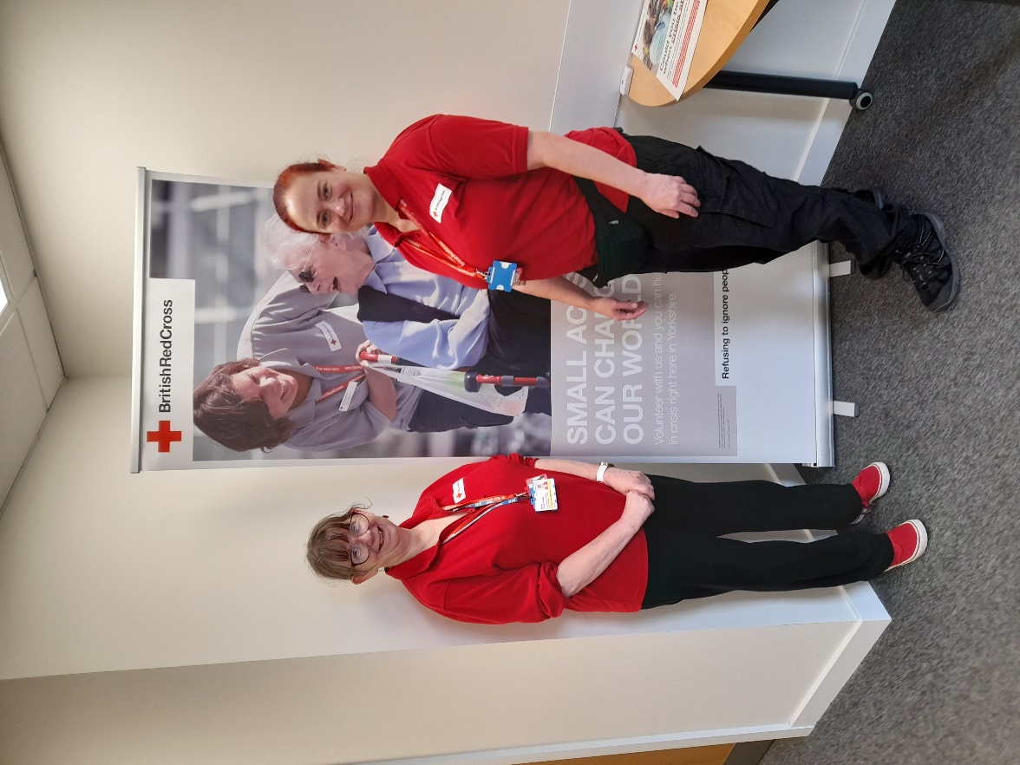

Thank you for reading. If you would like to join the Our Haxby Community meeting group, either as a local organisation representative or as an individual, to help shape and improve the care we provide, please let us know at: hnyicb-ny.haxbypatientexperience@nhs.net

If you would like to contribute any ideas for future newsletter editions, or to contribute a photo to champion your local team, please also let us know at the above email address.

