
Our Haxby Community Newsletter
Hull edition
September 2024
Carer awareness month

Message from Dr Witney, GP Partner
There are 5.7 million carers in the UK, and every day this number increases. A carer is anyone who provides unpaid care to a family member, friend or neighbour who has a disability or long-term illness, or who needs extra help as they grow older. We count many of you, our patients, in this number.

Carers play a vital role in helping those they care for get the most out life. Their positive contribution to families and society is profound, and often unrecognised. Many carers themselves do not realise their role or contribution. The carer role however, can often come at a cost. Whilst looking after others can be rewarding and meaningful, it can also be challenging and lonely. Carers themselves may struggle with their own poor health, life balance, and just keeping their head above water.

So please remember that you don’t have to care alone. Our local services (including our fantastic CISS team) can provide support, including respite support. If you know a carer who is making a difference and deserves an award then please use the adjacent QR code to nominate them for a CHAMPs Award (Caring, Helpful Amazing People). The closing date for this is midnight on September 30th. Let’s celebrate our unsung heros.

Who can help and where to look
- CISS: Support and information for adults who care for a loved one, family member or friend
https://www.chcpcic.org.uk/chcp-services/carers / 01482 222220
- Children and Young People’s Service: Support for all young carers and their parents
childcareservices@hullcc.gov.uk / 01482 300 300 / Text phone 01482 300 349
- West Hull Carers Support Group: Informal social support and helpful advice for carers
Every Tuesday 10:30am – 1:30pm at Hull Churches Home, Lindsey Place, Hull, HU4 6BS
01482 222220
- Carents Room: Help for adults caring for elderly parents
https://carents.co.uk/about/
- Special Stars: Offer a range of support, training and advice services for parent carers of children with learning and physical disabilities
https://www.heyspecialstars.co.uk/

What else is going on

National Food Bank Day

September 6th is World National Food Bank Day and we are partnering with Hull Food Bank to help them increase their supplies. Last year, they distributed over 11,000 food parcels to people in crisis in your area and we would like to help them continue this great work. There will be donation bins in your local practice from the 6th September and the week following. If you are able to contribute, please select something from the attached list and drop it into one of the bins. Every single donation counts, however small. Just one tin can make a huge difference.

Please look out for the donation crates in our waiting rooms!
Local team of the month
The Hull Carers Information and Support Service (CISS) team
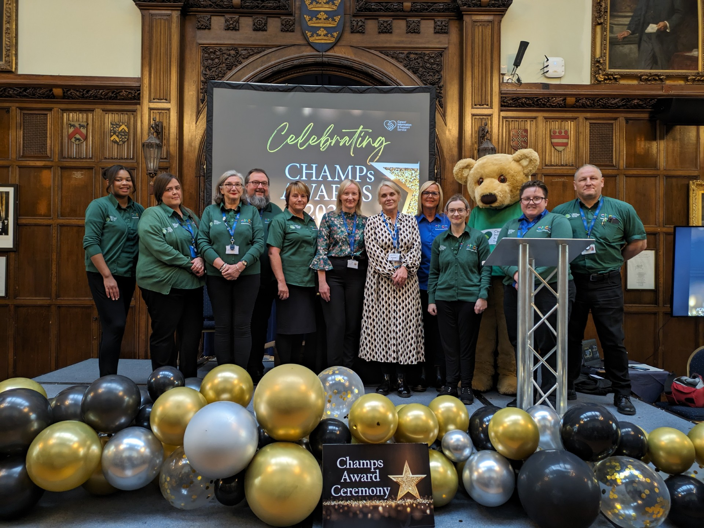
Thank you for reading. If you would like to join our Community Participation Group either as a representative of a local organisation or as an individual, to help shape and improve the care we can provide, please let us know at: hnyicb-ny.haxbypatientexperience@nhs.net

If you would like to contribute any ideas for future newsletter editions, or to contribute a photo to champion your local team, please also let us know at the above email address.

