
Our Haxby Community Newsletter
Hull edition
May 2024
Depression awareness month
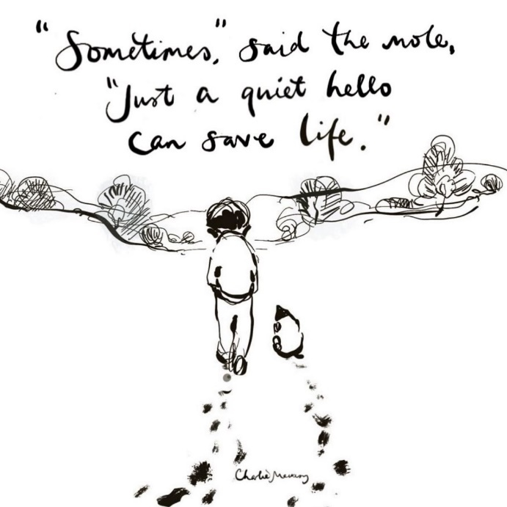
Message from Dr Witney, GP Partner
We’re often good at seeing what’s on the outside, but we can be less good at seeing what’s going on inside. It is one of life’s true clichés that everyone is fighting a battle that you know nothing about.

There are many ways out of depression, but these paths are often not clear for those who are suffering with it. This month we’re encouraging everyone to reach out to anyone who they think may be struggling with their mental health. Your help may be worth more than you think.

If you yourself feel depressed and unable to cope, please contact us, or one of the teams below. We are here to help.

Who can help and where to look
- Crisis Team Hull: If you are in a crisis with your mental health (available 24/7)
0800 138 0990 / https://www.humber.nhs.uk/Services/mental-health-crisis-team.htm
- Hull Talking Therapies: Self-referral for free Hull-based counselling and support
01482 247111 / https://www.letstalkhull.co.uk/
- Thrive Hull: Local support options for young people struggling with their mental health
https://www.howareyoufeeling.org.uk/young-people/
- Andy’s Man Club: Weekly meetings for men suffering with depression (Monday 7pm)
https://andysmanclub.co.uk/ / info@andysmanclub.co.uk
- First Ladies Club: Weekly meetings for women managing their mental health (Wednesday 7pm)
https://www.facebook.com/FLCHull/ / Info@firstladiesclub.co.uk
- Mind: For anyone wanting information on mental health support for themselves or a loved one. Includes an information line
01482240133 / https://www.mind.org.uk/

What else is going on

The Mental Health Foundation are celebrating Mental Health Awareness Week from 13th May. The theme this year is Movement: Moving more for our mental health. It’s a great theme, with exercise being an important and often neglected part of maintaining good mental health. It can be tricky to fit into our lives, so see below on some tips for how to make this easier!

https://www.mentalhealth.org.uk/our-work/public-engagement/mental-health-awareness-week/boost-your-mental-health-moving-more

Our next Patient Participation Group meeting will be held on Tuesday 28th May at 11:00

Poem of the month
Time to share

Hearts in high
Hands in deep
A story to hear
A life to keep
Past trauma
Of another kind
Fills our room
Fills our mind

Addiction, prescription
Tears and why?
We try, we say
We try, we try
We try to lift
We try to catch
We try to share a story
Snatched
From us by the time
And I hear you say
“it’s fine, it’s fine”

Missed appointment
Missed the bus
(Missed again)
Do you trust
That we won’t judge
We’ll know as such;
Who you are
That you are us
Thank you for reading. If you would like to join our Patient Participation Group either as an organisation or as an individual, to help shape and improve the care we can provide, please let us know at: hnyicb-ny.haxbypatientexperience@nhs.net

If you would like to contribute any ideas for future Newsletter editions, or to the monthly poem, please also let us know at the above email address.

