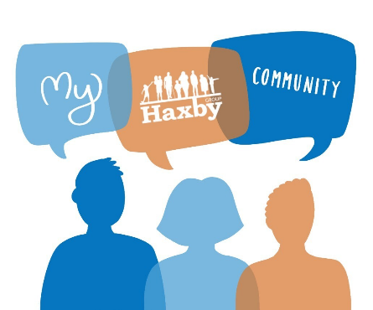
Our Haxby Community Newsletter
Hull edition
June 2024
Pride month
Message from Dr Witney, GP Partner
It’s officially Pride month!

Pride month is celebrated annually in June, to honour our lesbian, gay, bisexual, transgender and queer community. Its aim is to both celebrate this community, and to highlight some of the issues they still face in our society.

The theme of Pride this month has got me thinking about the importance of human dignity in health and wellbeing, and the harm caused by pride’s opposite – shame. This is the feeling of being negatively judged by others as flawed or inadequate, and evidence has shown that that a persistent feeling of shame worsens not just our quality or life, but also our health itself. We know that our minority communities are more vulnerable to this, and it serves as a good reminder to treat everyone with dignity and respect.

If you are a member of our LGBTQ+ community, please remember that your right to routine breast and cervical screening is the same as any other patient, as is your right to be assessed without judgement.
Who can help and where to look
- Hull and East Riding LGBT forum: Please feel free to attend their regular community meetings held on second Wednesday of every month, 18:30 at the Guildhall in Hull
https://www.facebook.com/groups/35292841599/
- Switchboard mental health support: LGBTQ+ mental health support
https://switchboard.lgbt/ / 0300 330 0630 (10am – 10pm every day)
- The Warren: Support groups and safe space for LGBTQ+ youth aged 11-17 and 16-25
https://www.thewarren.org/lgbtq
- Trans Hull: Welcoming LGBTQ+ community with a particular focus on trans+ folks
https://www.facebook.com/transhullofficial/ transhull89@gmail.com
- TPSG Hull: Adult trans peer support group in Hull
https://www.facebook.com/TPSGhull/
- Trans Youth Hull: Support group for identity questioning young people and their parents
tyouthhull@gmail.com (sessions run on the first Sunday of every month)

What else is going on

There has been a lot of coverage in the news around motor neurone disease (MND) with rugby league legend Rob Burrow sadly passing away recently. In light of this, we’ve decided to donate our Euros staff sweepstake winnings to a local legend, 7 year old Jack, who is running a total of 20km throughout July, to raise money for the Motor Neurone Disease Association and for his dad. We hope to cover this devastating disease in a future newsletter.

If anyone would like to donate to this fantastic cause, please do so below. Go on Jack!

www.justgiving.com/page/jack20km

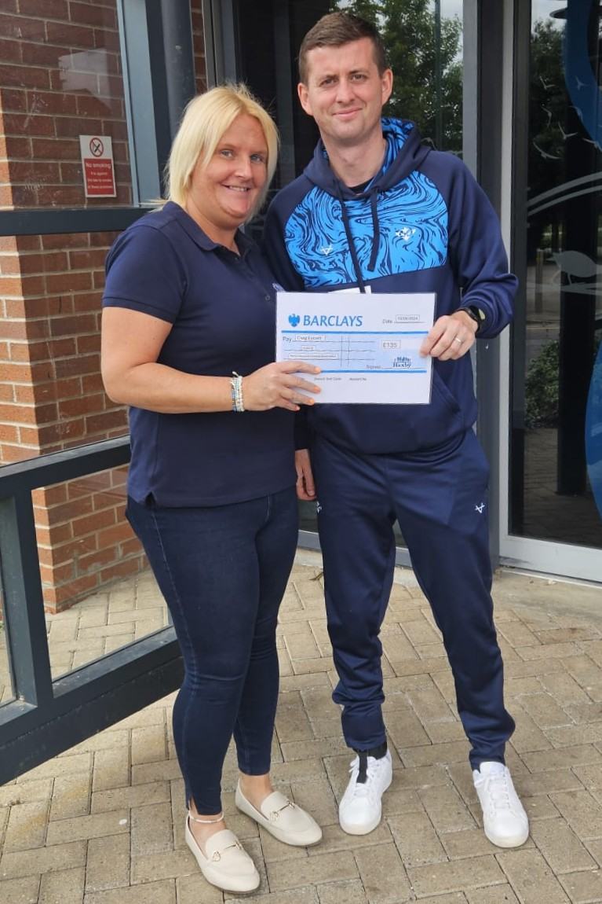
Jack’s dad, Craig, receiving our donation from staff member, Sarah Cooper
Thank you for reading. If you would like to join our Community Participation Group either as an organisation or as an individual, to help shape and improve the care we can provide, please let us know at: hnyicb-ny.haxbypatientexperience@nhs.net

The next Community Participation Group meeting will be on 29th July

If you would like to contribute any ideas for future newsletter editions, or to contribute a photo to champion your local team, please also let us know at the above email address.

