
Our Haxby Community Newsletter
Hull edition
July 2024
Endometriosis awareness month

Message from Dr Witney, GP Partner
Endometriosis is not a medical condition commonly discussed by the public or the media, but it certainly should be. Around 1 in 10 women will have this condition, about the same number of women who have diabetes and asthma: both currently much better recognised conditions.

Endometriosis occurs when body cells similar to the cells in the lining of the womb start growing in other places, such as the ovaries and fallopian tubes (although they also grow elsewhere in the body). It is a long-term condition and can have a significant impact on your life. It can also cause difficulties getting pregnant.

We know that endometriosis diagnoses can often be missed, with some studies estimating a considerable delay in diagnosis of up to 10 years. We also know that some women experience discrimination in the medical setting when seeking help.

So, if you are woman with any unexplained pelvic pain, period-related pain, or deep pain during or after sex, if you have cyclical painful peeing or pooing, or unexplained blood in your wee, please do not hesitate to get in touch with us. We are here to help. Please also see below for information relating to our excellent local support groups.

Who can help and where to look
- HEY Endo: Local support group for anyone in Hull and East Riding with endometriosis
https://linktr.ee/heyendo
- Endo Buddies: Provide care packages and materials for women with endometriosis
https://endobuddies.com
- Endometriosis UK: National website, for information and support. Also have a helpline
https://www.endometriosis-uk.org/ / 0808 808 2227
- Endometriosis NHS: General NHS information on the condition
https://www.nhs.uk/conditions/endometriosis/

What else is going on

On Saturday 26th October the HEY Endo team will present "Unmasking The Mystery" – a fun night of fundraising and awareness for endometriosis research.

The dress code will be formal masquerade and there’ll be a hot food buffet, DJ, live auction and raffle.

It will be held at: Village Hotel, Henry Boot Way, HU4 7DY. 7:30pm – late.


Get your tickets for this fantastic event, here!

Local team of the month
The HEY Endo team
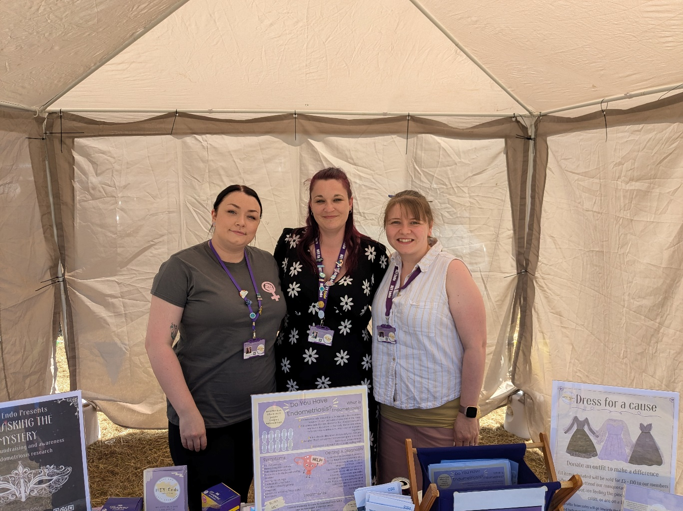
Thank you for reading. If you would like to join our Community Participation Group either as a representative of a local organisation or as an individual, to help shape and improve the care we can provide, please let us know at: hnyicb-ny.haxbypatientexperience@nhs.net

The next Community Participation Group meeting will be on 29th July

If you would like to contribute any ideas for future newsletter editions, or to contribute a photo to champion your local team, please also let us know at the above email address.

