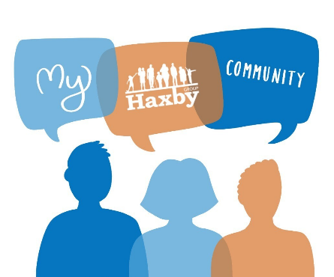
Our Haxby Community Newsletter
Hull edition
August 2024
Breastfeeding awareness month

Message from Dr Witney, GP Partner
The multiple benefits of breastfeeding are well known. These include:

- Increased protection provided to your baby from infections
- Helping to improve your baby’s long-term health into childhood and adulthood
- Reduced risk for your baby of childhood diabetes, certain types of cancer (such as leukaemia) and reduced risk of SIDS (sudden infant death syndrome)
- Improved bonding with your baby and recovery from pregnancy
- Reduced risk for maternal breast cancer, ovarian cancer, diabetes and heart disease

Starting and continuing breastfeeding is not always simple however, and there are many challenges which new mums can experience. Our UNICEF Gold Award winning Infant Feeding Team in Hull can help support you with any of these issues. Their team can meet with you either during pregnancy or after birth, regardless of the baby’s age. If you are struggling with breastfeeding, or have concerns or questions, please get in touch. Their contact details and other relevant information are included below.

Who can help and where to look
- Infant Feeding Team: Single point of contact for infant feeding / breastfeeding concerns
01482 259600
- Goodwin Trust: Breastfeeding peer support service, including breast pump loan service
01482 497811
- The Pink Sheet: All breastfeeding support resources for our area
https://www.familyhubshull.org.uk/downloads/file/20/breast-feeding-support
- Family Hub breastfeeding information: Local information and help with breastfeeding
https://www.familyhubshull.org.uk/parenting-advice-information/infant-feeding/6
- NHS Start for Life: General NHS information and advice on breastfeeding
https://www.nhs.uk/start-for-life/baby/feeding-your-baby/breastfeeding/

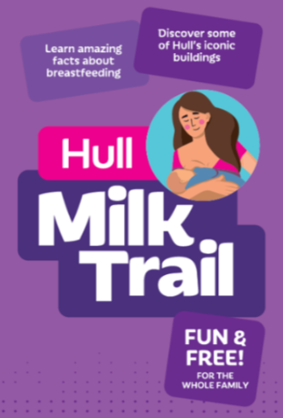
What else is going on

Fancy doing the Milk Trail?

The team led on the development of a City Trail centred around breastfeeding, which was launched in June. The Milk Trail was designed to promote over 120 breastfeeding friendly premises that are available in and around Hull. For some new mothers, breastfeeding in public places can feel intimidating and the Milk Trail aims to encourage and provide support to those that need it, alongside offering education about breastfeeding to the general public. Join in via the below QR code!



Local team of the month
The Infant Feeding Team - Debbie, Ellie, Beth and Sarah (left to right)
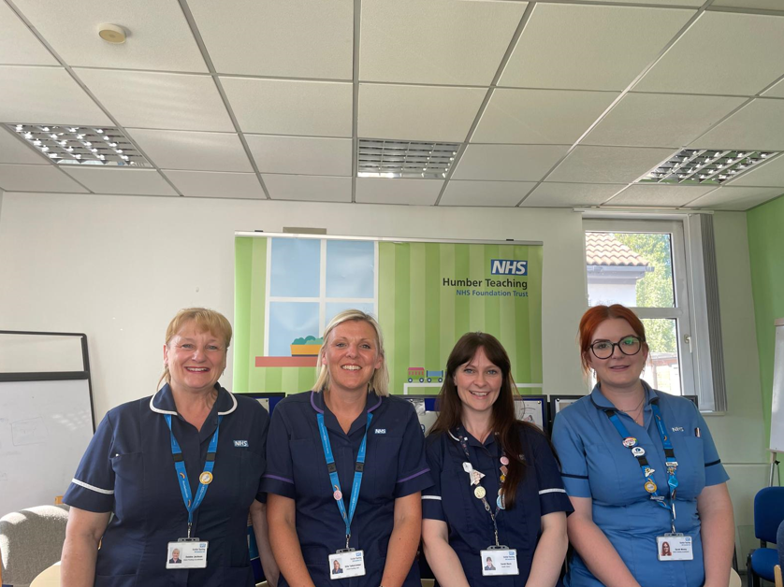
Thank you for reading. If you would like to join our Community Participation Group either as a representative of a local organisation or as an individual, to help shape and improve the care we can provide, please let us know at: hnyicb-ny.haxbypatientexperience@nhs.net

If you would like to contribute any ideas for future newsletter editions, or to contribute a photo to champion your local team, please also let us know at the above email address.

