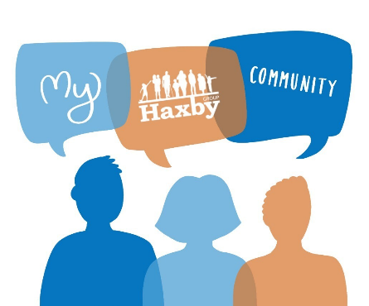
Our Haxby Community Newsletter
Hull edition
February 2024
Eating disorder awareness month
Message from Dr Witney, GP Partner
We don’t have to try very hard to see that food is an important part of all our lives. It keeps us alive for starters (no pun intended). It also fuels our energy and nutritional requirements, the growth and development of our children, and can add real enjoyment and quality to our days.

Unfortunately, it is not always possible to keep a healthy relationship with food. People with eating disorders use disordered eating behaviour to help them cope with difficult feelings and situations. There are many different types of eating disorder, but all who suffer with them require compassionate and understanding care to help them recover.

Eating disorders are complex mental illness and we know that anyone, regardless of age, gender, ethnicity, or background can be affected. The impact of disordered eating is also often felt by the whole family, which it is why it is also important for those supporting someone with an eating disorder to receive support themselves. Full recovery from an eating disorder is possible with the right help. Please see below for some excellent services who can support with this.
Who can help and where to look
- Evolve Hull: 1-1 and group intervention support for any adults with problems with food
https://www.chcpcic.org.uk/chcp-services/evolve-hull-community-eating-disorder-service/pages/evolve-referrals / 01482 344083
- SEED Hull: Support, advice and signpost sufferers, carers and loved ones appropriately, by giving people the tools to enable them to cope on a daily basis
https://seed.charity/ / 01482 718130
- SEED Recovery after the recovery (RATR): For anyone in Hull aged 11-25 with an eating disorder or disordered eating who would like to start their journey to recovery
https://seed.charity/recovery-after-the-recovery/#1693378999227-c7f26bc6-95a4 / ratr@seed.charity
- CAMHS Eating Disorder Service: Offer support from a range of professionals for children under the age of 18 and their families
01482 347886
- Beat: Online support and resources
https://www.beateatingdisorders.org.uk/ / Helpline: 0808 801 0677
- FREED: Service for 16 to 25-year-olds who have had an eating disorder for 3 years or less
https://freedfromed.co.uk/

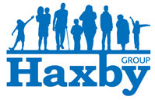
What else is going on

You may have seen recent coverage regarding the new ‘Pharmacy First’ scheme, which started on 31st January and can now be used by anyone in Hull.

The scheme allows patients to receive treatment for seven common conditions without the need for a GP appointment. You can access this new service by walking straight into the pharmacy, or by being referred by 111 or the GP.

The conditions for which this service can be used are: sore throat, ear ache, sinusitis, impetigo (a common skin infection with sores and a crusty appearance), shingles, infected insect bites, and uncomplicated urinary tract infections in women. If the pharmacist suspects a more complicated condition, they will be able to refer you to the GP.

Please remember that pharmacies already offer help with medication advice, contraception, and blood pressure checks, should this be needed.
Our next Patient Participation Group meeting will be held on February 19th

Poem of the month
Sunrise over Hull

Rows of grey houses
Flash by
Huddled together in the morning dim
But unnoticed behind
Is the sky
Lit by holy fire
Rising with tangerine veils
On a white-hot sea
Saying, this is life
And all beyond
This is where we live our days
Thank you for reading. If you would like to join our Patient Participation Group either as an organisation or as an individual, to help shape and improve the care we can provide, please let us know at: hnyicb-ny.haxbypatientexperience@nhs.net

If you would like to contribute any ideas for future Newsletter editions, or to the monthly poem, please also let us know at the above email address.

